# Project: Product Shop

Product Shop is a system that registers users, categories, products and orders. It is a significantly big project, and as such it will have several parts. In this exercise you will land the basics of the application, in other words - the user functionality.

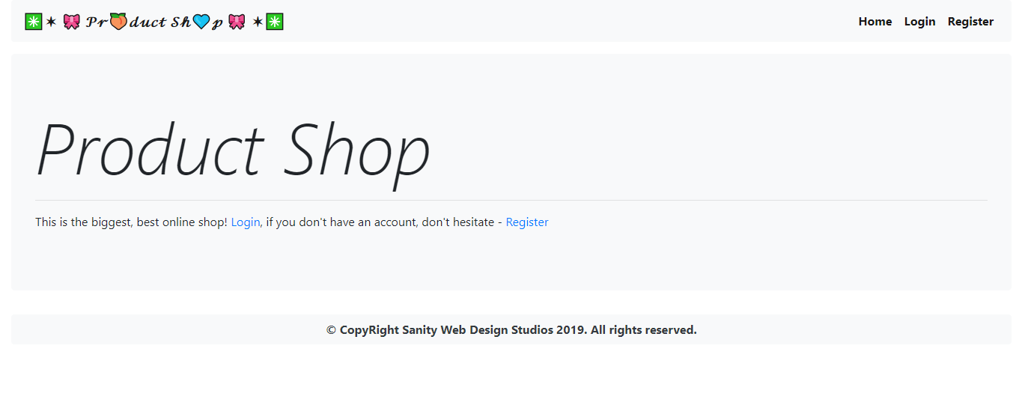

# Workshop: Part 2 - Products

## Views

These are the additional views you must implement.

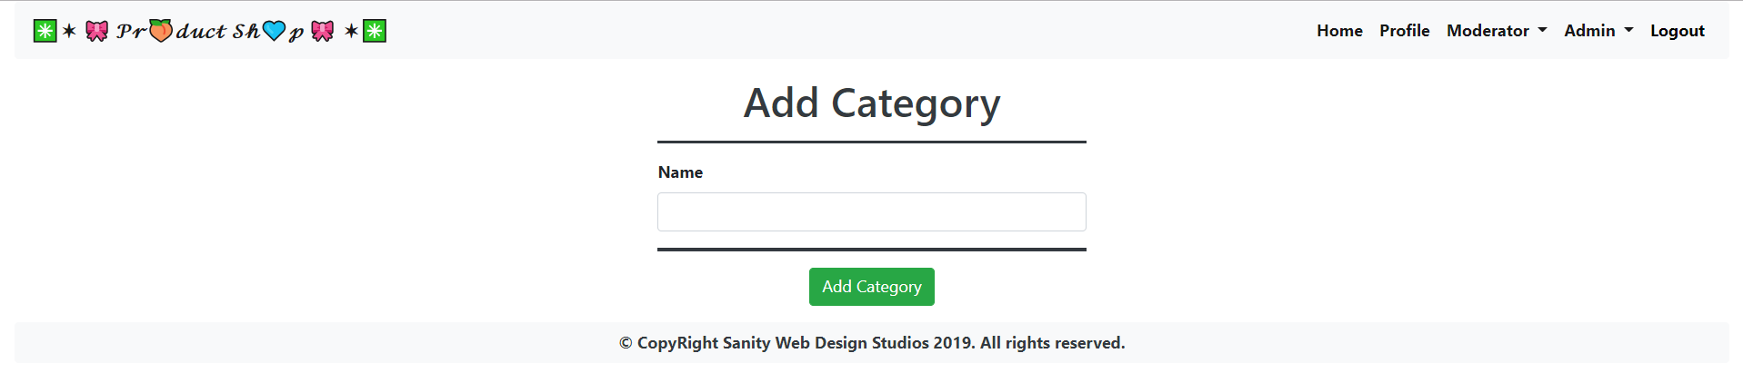

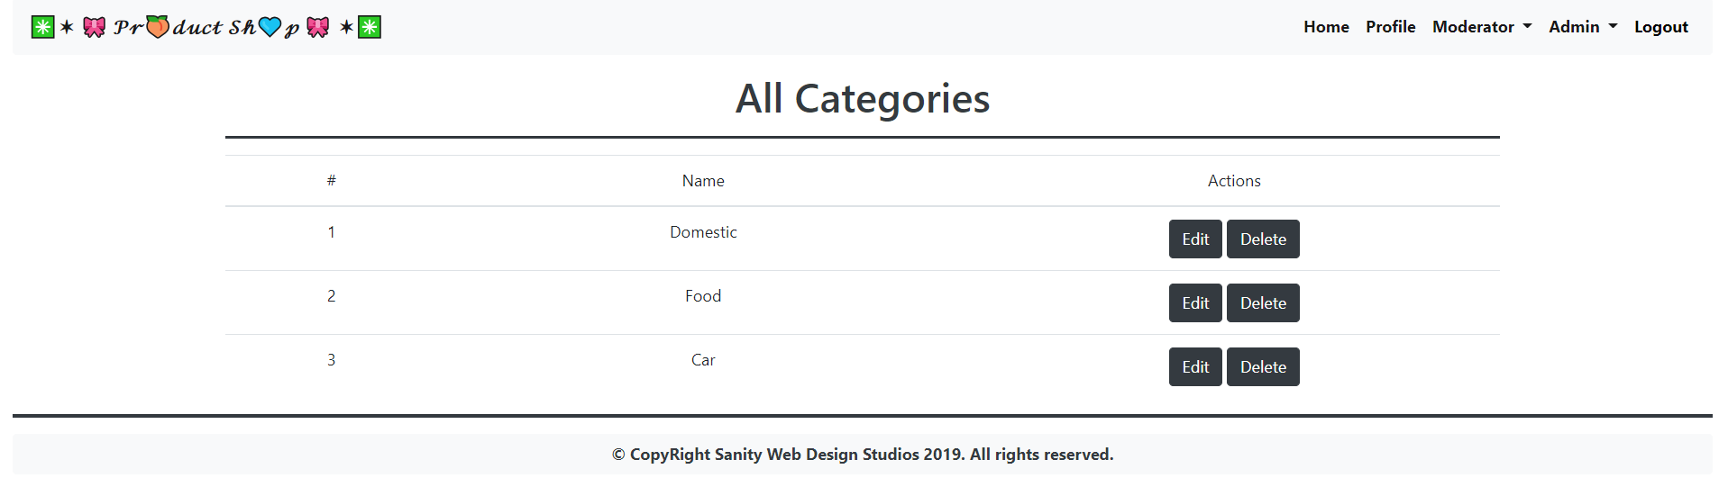

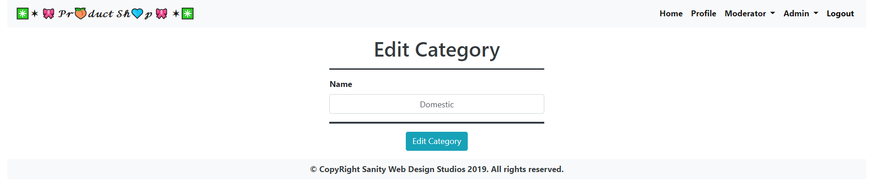

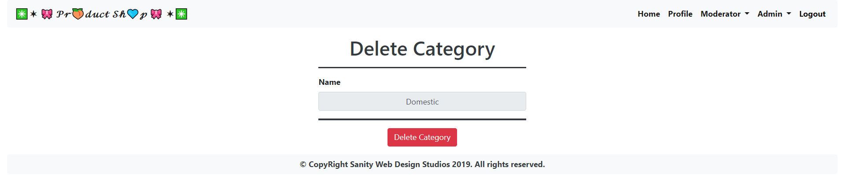

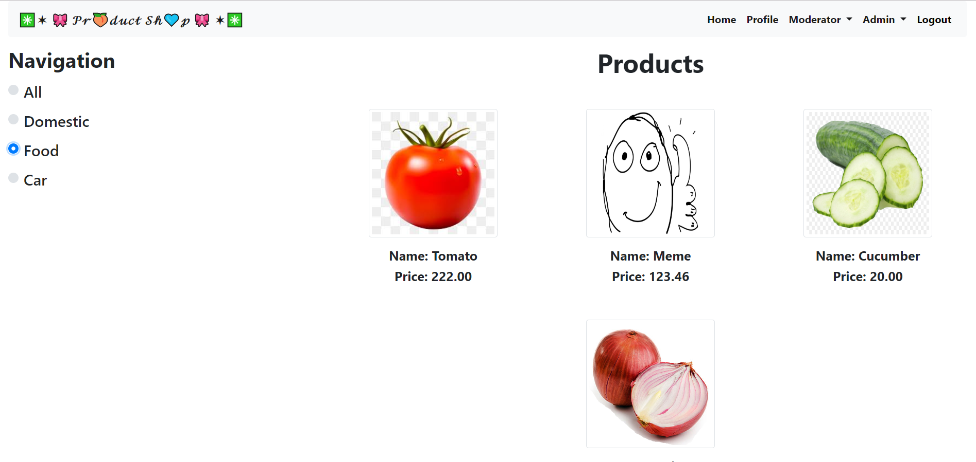

**NOTE**: The **Navigation** contains all of the added categories as radio buttons. Depending on your selection of a **radio** button, you should render different products. If you select the [All] button you should render all products.

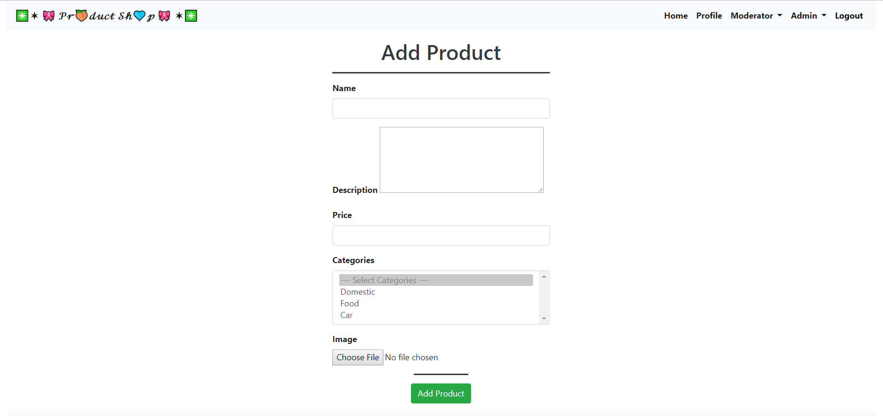

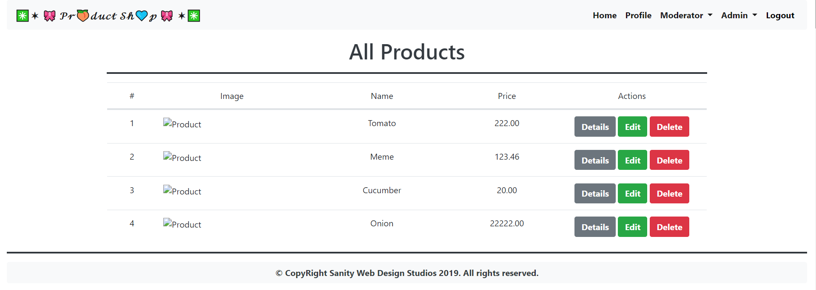

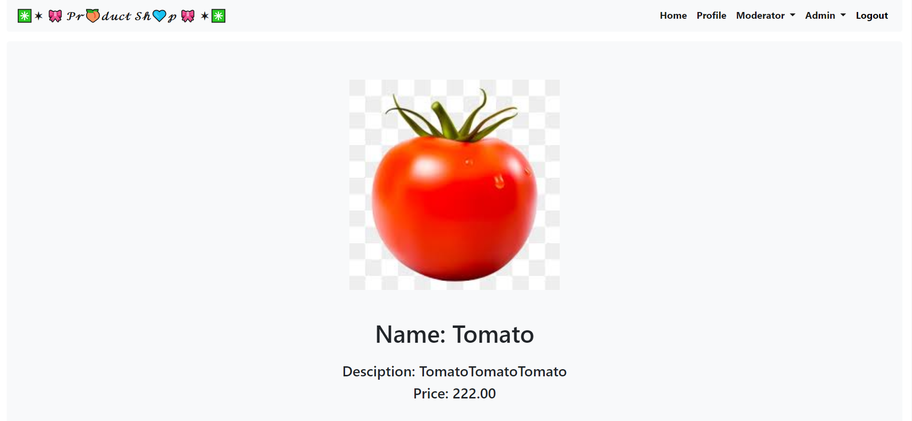

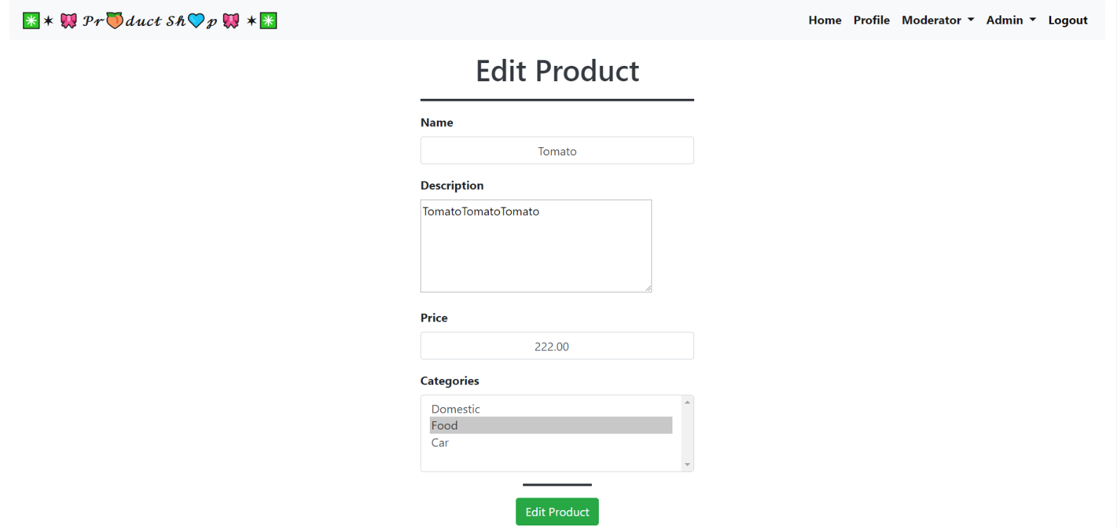

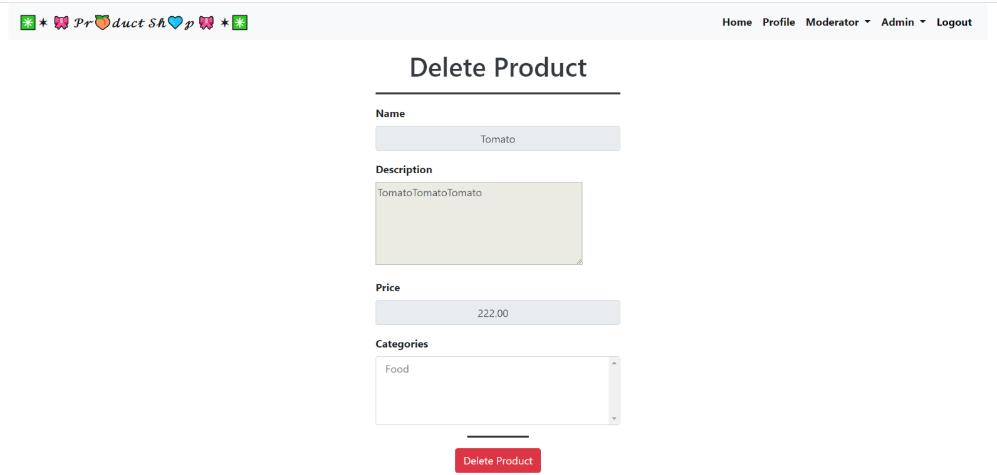

## Data Entities

Create the required **entities**. Use the appropriate **data types**. In this exercise you will have Users and their Roles

* **Product**
  + **Id –** primary key, universally unique identifier
  + **Name –** string
  + **Description –** string
  + **Price** – a floating-point number
  + **ImageUrl** – a string
  + **Categories –** a collection of **Category** objects.
* **Category**
  + **Id –** primary key, universally unique identifier
  + **Name -** string

## Establish the Back-End

Create the required:

* **Entities**
* **Models**
* **Repositories**
* **Services**
* **Controllers**

## Functionality

### Categories

Implement all **CRUD** operations for the **Categories**. They should be pretty simple as the entity itself is not that complex.

### Products

Implement all **CRUD** operations for the **Products**. NOTE: You cannot **edit** the **image** of the **Product**.